ALL NEW EUROPEAN HIGHLIGHTS - 2025
8 NIGHTS & 9 DAYS
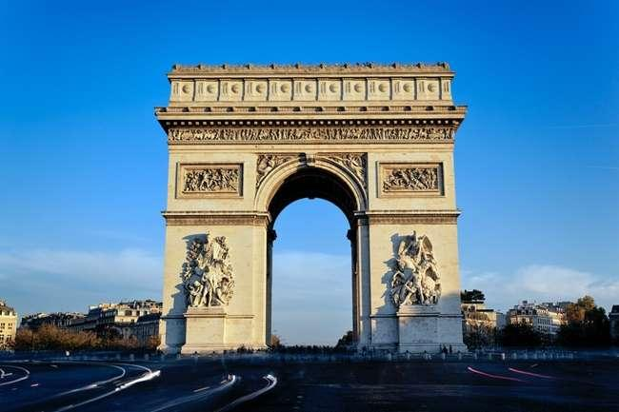

IMP Factors
- Value-for-Money holiday which you will cherish for a lifetime
- Visit 4 countries in 9 days: France, Switzerland, Italy and Vatican City
- All Important attractions and sightseeing included. Eiffel Tower 2nd level, Entrance to Fragonard Perfumery, River Seine Cruise, Excursion to Jungfrau included, Excursion to Mt. Titlis, Visit St. Mark’s Island in Venice, Visit Leaning Tower of Pisa, get a panoramic view of Florence from Piazzale Michelangelo, Orientation tour of Rome, Visit St. Peter’s Basilica, Vatican City only and Trevi Fountain
- Guided tour in Paris
- Services of a Professional & Knowledgeable Tour Manager accompanying you throughout the tour
- Accommodation in 3 & 4-star hotels
- Daily Continental buffet breakfast.
- Delicious unlimited variety of Jain, Veg and Nonveg Indian cuisine as per itinerary.
- Daily mineral water bottle (500ml) per person

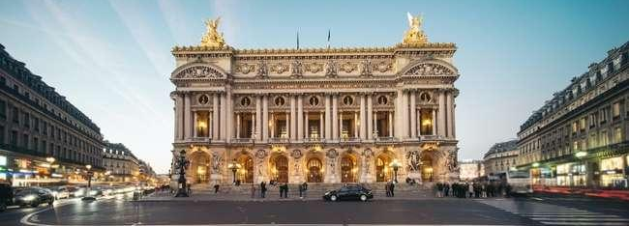
Opera Garnier

Day 1
Arrive into Paris – the City of Romance, Lights and Glamour.
Hello! Today, we begin our adventure to Paris, a renowned city known for its exceptional fashion, renowned museums, breathtaking landmarks, and captivating cabaret scenes. Upon reaching your destination, our Tour Manager will extend a warm welcome, assist you with hotel check-in, and be available to support you throughout your stay.
Overnight stay at hotel in Paris. (Dinner)
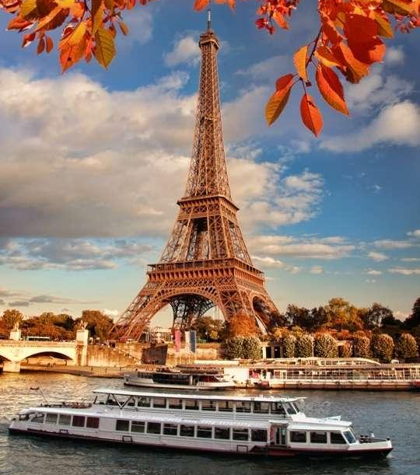
Day 2
Guided city tour of Paris. Visit to Eiffel tower 2nd Level. Enjoy a romantic cruise on River Seine. Visit Fragonard French perfumery
Today, we commence our guided exploration of Paris, offering you the chance to admire some of its most renowned landmarks. Our schedule includes stops at iconic sites such as Place Vendôme, Place de l’Opéra Garnier, Musée d’Orsay, Place de la Concorde, Champs Elysées (famously known as one of the world's most fashionable avenues), Arc de Triomphe, Alexander Bridge, Les Invalides, and many other notable locations.
Next on our agenda is a visit to the second level of the iconic Eiffel Tower, where you can indulge in a breathtaking panoramic view of the city. With its unmistakable tapering cast iron pinnacle, the Eiffel Tower symbolizes not just Paris but the entire nation of France. Later in the day, we embark on a romantic cruise along the Seine River, providing one of the most picturesque vistas in the world. As we glide beneath charming bridges, you'll be treated to views of exquisite monuments including Notre Dame, the Eiffel Tower, the Louvre, the Orsay Museum, and many others. This relaxed cruise allows you to appreciate the beauty of Paris from an extraordinary vantage point, right in the heart of the vibrant city.
Eiffel Tower
Our journey continues with a visit to the Fragonard Perfumery, an essential destination in Paris. This museum is devoted to the intriguing realm of fragrances, where you can uncover the secrets behind the art of crafting French perfumes.
Overnight stay at hotel in Paris. (Breakfast, Lunch, Dinner)

Day 3
Drive to scenic Switzerland.
After checking out from your hotel, we will begin our journey towards Switzerland, a picturesque Central European nation characterized by its mountainous terrain, pristine lakes, charming villages, and the towering peaks of the Alps. As we embark on this scenic drive to Switzerland, you'll be treated to breathtaking landscapes. Switzerland's mountains and valleys are renowned as some of the most awe-inspiring in the world, promising stunning vistas at every turn.
During your drive through these mountain passes, you'll encounter remarkable landmarks and sites of historical significance.
Upon reaching Switzerland, we will proceed to your hotel, where you can check in and unwind in the cozy comforts of your accommodation.
Overnight stay at hotel in Central Switzerland. (Breakfast, Packed Lunch, Dinner)

Day 4
Enjoy a magical alpine excursion to the top of Europe - the amazing Jungfraujoch which is included in your tour and scenic Interlaken.
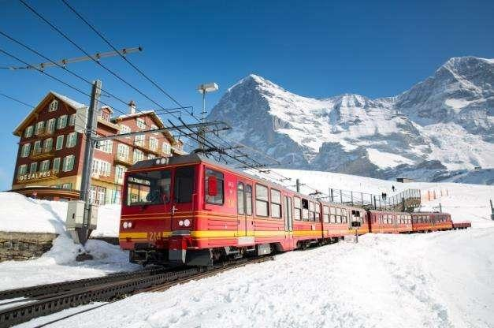
Get set for a memorable magical alpine excursion to Jungfraujoch – The Top of Europe, a high–point of your tour. First proceed to Grindelwald Terminal. The new 3S-Bahn Eiger Express takes you from the Grindelwald Terminal to the Eigergletscher station in just 15 minutes. There you board a cogwheel train to reach the highest railway station in Europe at 11,333 feet – a world of eternal ice and snow. Visit the Ice Palace where artistes create their work of art in ice. Visit the Sphinx observatory deck to experience a breath-taking panoramic view of the longest glacier in the Alps - Aletsch Glacier.
Cogwheel Train to Jungfraujoch included
Overnight stay at the hotel in Central Switzerland. (Breakfast, Lunch, Dinner)

Day 5
Visit Mt. Titlis- enjoy Cable car rides including the world’s first rotating cable car, the Rotair – to the top of Mt. Titlis at 3,020 metres. Orientation tour of Lucerne.
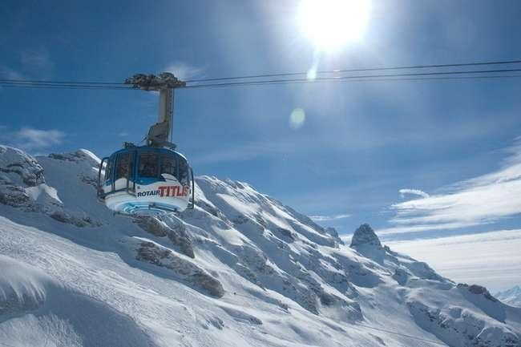
Free time for shopping. Drive to Lugano.
Today holds the promise of an extraordinary adventure as you immerse yourself in the breathtaking landscapes of Switzerland. Check out from the hotel as we proceed to the summit of Mt. Titlis, a once-in-a-lifetime experience that involves ascending to an impressive altitude of 3,020 meters through a series of cable cars, including the Rotair, the world's first revolving cable car. From this lofty vantage point, you'll be treated to an awe-inspiring, unobstructed 360-degree view of the glistening, snow-covered peak, deep crevasses, and pristine white snowfields adorned with massive ice boulders, visible from every angle. Don't forget to explore the "Cliff Walk," Europe's highest suspension bridge, which clings to the cliffs of Mt. Titlis and provides an exhilarating perspective.
ROTAIR to Mt. Titlis
Later in the day, your adventure continues with an orientation tour of Lucerne, widely regarded as one of Switzerland's most enchanting cities. Your tour will encompass visits to the iconic Lion Monument and the historic Kapell Brucke. You'll also have some free time for shopping, where you can peruse and purchase famous Swiss watches, knives, and delectable chocolates. Later drive to Lugano and check in to your hotel.
Overnight stay at hotel in Lugano. (Breakfast, Lunch, Dinner)

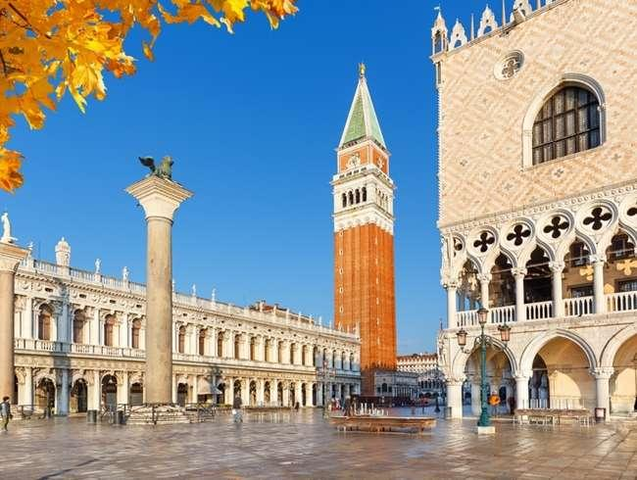
Day 6
Welcome to Venice - the floating city of Italy.
After checking out of your hotel, our journey leads us to Venice, Italy, a city celebrated for its magnificent monuments, meandering canals, and its enduring ability to inspire poets and romantics throughout history. Upon reaching the pier in Venice, we will board a private boat.
This scenic route will guide you to St. Mark’s Square, the central and most iconic square in Venice. Here, you can admire the architectural masterpiece that is St. Mark’s Basilica, a shining example of Byzantine design. Take in the view of the renowned Bell Tower and Clock Tower, both of which feature a captivating representation of the Zodiac sign and the current moon phase.
St. Mark’s Square
As you continue your exploration, you'll encounter the Bridge of Sighs, an elegant structure crafted from white limestone, spanning the Rio di Palazzo and connecting the old prisons to the interrogation rooms at the Doge’s Palace.
Following this memorable tour, we'll return to the pier and proceed to check in to your hotel, where you can unwind and relax.
Overnight stay at hotel in Padova (Breakfast, Lunch, Dinner)
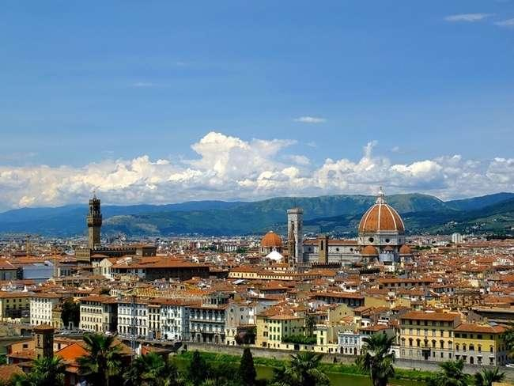
Day 7
A visit to the world-famous Leaning Tower of Pisa. Photostop at Piazzale Michelangelo.
Post Breakfast, Check out and proceed towards Pisa – visit the Square of Miracles recognized as an important center of European medieval art and one of the finest architectural complexes in the world. See the remarkable Leaning Tower of Pisa. as you complete the check-out process at your hotel, we will commence our journey to
Piazzale MIchelangelo
Florence's most renowned viewing point – Piazzale Michelangelo. This location boasts the most iconic panoramic vista of Florence, functioning as a splendid terrace that offers breathtaking views of the city. It is named in honor of one of the most significant artists of the Florentine Renaissance: Michelangelo Buonarroti.
Overnight stay at hotel in Tuscany region. (Breakfast, Lunch, Dinner)

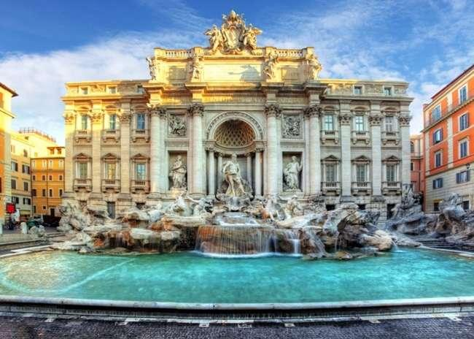
Day 8
Drive to the eternal city of Rome. Visit the world’s smallest country – the Vatican City and St. Peter’s Basilica only.
Today, we drive to the eternal city of Rome. Our first destination is the Vatican City, the world's smallest independent country. Here, you'll have the opportunity to explore the exquisitely beautiful St. Peter's Basilica, where you can marvel at the magnificent works of art created by masters such as Michelangelo and Bernini.
Our exploration of Rome continues to see the awe-inspiring Colosseum, an immense amphitheater that has endured the passage of centuries, retaining its grandeur and historical significance.
Trevi Fountain
Our next stop on the itinerary is the enchanting Trevi Fountain. According to legend, tossing a coin over your shoulder into the fountain guarantees your return to Rome, making it a cherished tradition among visitors. Check in to your hotel.
Overnight in Rome. (Breakfast, Lunch, Dinner)

Day 9
Fly back home
As your memorable holiday comes to a close, today marks the day to return home. Bid farewell to the wonderful new friends you've made during this tour. It's time to check out and make your way to the airport, carrying with you the pleasant memories of your European journey—a treasure you'll cherish for a lifetime. Safe travels! (Breakfast)

Inclusion: Sightseeing and excursions

FRANCE
Paris
- City tour with a local guide
- Visit to the 2nd level of the Eiffel Tower
- Enjoy romantic cruise on River Seine
- Entrance to Fragonard Perfumery

SWITZERLAND
Interlaken
- Excursion to Jungfraujoch - Top of Europe
- Visit scenic Interlaken
Engelberg
- Witness breath-taking mountain peaks and glaciers at Mt. Titlis
- Ride in the world’s first revolving cable car
- Walk on the Highest suspension bridge in Europe - Titlis Cliff Walk
Lucerne
- Orientation tour of Lucerne

ITALY
Venice
- St. Mark’s square by Private boat
Florence
- Photostop at Piazzale Michelangelo – panoramic view of Florence
Pisa
- Visit Square of Miracles
- Photo-stop at the Leaning Tower
Rome
- Orientation tour of Rome
- Photostop at the Colosseum
- Visit to Trevi Fountain

VATICAN CITY
Vatican City
- Visit the magnificent St. Peter’s Basilica only

Accommodation:
- 02 nights accommodation in a B&B / Ace or similar hotel in Paris
- 02 nights accommodation in a Dormero / Du Parc or similar hotel in Central Switzerland
- 01 night accommodation in a Hotel Serpiano or similar hotel in Lugano
- 01 night accommodation in a Blue Dream / B&B or similar hotel in Padova / Ferrara
- 01 night accommodation in a Fortuna Resort / Park or similar hotel in Tuscany
- 01 night accommodation in a B&B / Pineta or similar hotel in Rome

Meals
- Daily Continental Buffet Breakfast.
- 7 Indian Jain/Vegetarian/Non-Vegetarian Lunches.
- 8 Indian Jain/Vegetarian/Non-Vegetarian Dinners.

Instruction for Arrival & Departure Coach Transfers:
Paris (CDG Airport) Arrival Transfer – Flight landing time should be between 08 AM – 02 PM.
Rome (FCO Airport) Departure Transfer: The coach will drop at Airport by 1100 AM.
IMP Notes for Transfers:
- Please advise your client that there may be waiting up to 02 Hours (Post reaching in arrival hall) for arrival transfers.
- If flight timings are before / after the suggested timing, client has to arrange his private transfers on a direct payment basis. We will not reimburse any cost for private transfers.

What your tour price does not include:
- The cost of the Airfare, Passport, POE charges, Visa charges, Overseas Travel Insurance, etc.
- Any expenses of personal nature such as Porterage, Laundry, and Alcohol, Food or Drink not in the regular menus provided by us, mini bar and telephone calls
- Any extra meals not included in the itinerary. Meals are pre - set and a choice of menu is not available
- Tour guide and driver tips will be added in Final payment and collected with final payment.
- Cost of excursions, city sightseeing, entrance fees and local guides availed of by the passengers, other than that mentioned in ‘What your tour price includes’
- GST, TCS and other taxes as applicable
- Anything which is not specified in the Itinerary

NOTES:
- A person below 12 years of age on the entire tour will be considered a child
- As a 3rd person in a triple room, most hotels use rollaway beds and room size may be the same as the double room
- Tours will operate subject to all Government regulations
- All Local taxes, entrances and services are calculated as on 1st October 2024, any increase in local taxes, entry tickets and other services has to be borne and paid by the traveler/agent.
- All transfers and extensive sightseeing with entrance fees (as specified in the itinerary) will be done in an air-conditioned coach
- On reaching Eiffel Tower, if there is a very long queue, we will be taking you to the Montparnasse tower
- It is suggested to carry One check in bag and one hand bag per person only, due to limited boot space in the coach
- Services of our Tour Manager or local representatives, while on tour
- On some occasions, you may have to join another group in case your group does not have adequate members
- A local representative or your coach driver may only be there to assist you during your initial part of the tour
- Land surcharges applicable on certain departure dates which will be notified
- If certain sightseeing/excursions are closed, then alternate sight- seeing will be arranged.
- Kindly note that on certain departure dates the tour routing could change. In some tours, there is also a possibility that the tour could operate in reverse itinerary. However, you will not miss any sightseeing or excursions that are mentioned in the itinerary unless its closed due to a holiday. Your Tour Manager will notify you the same
- In case of inordinate delays and strict driving laws, packed dinner may be provided on that day
- Please check with your Sales representative for final details
- In case of any increase in any taxes in Europe, there would be a change in price which will be justified
- We reserve the right to claim from the passengers, any additional expenses incurred due to delay or changes in the schedule of trains, flights, coach, cruise or other services
- We reserve the right to change any itinerary for operational reasons and reasons beyond the control of us due to Force Majeure related to weather conditions, strike, etc. Force Majeure related to weather conditions, strike, etc.
- We shall not accept any liability or responsibility for any damages, loss, injury, accident, death, delay, breakdown or irregularity, which may occur during the tour, due to weather conditions, strikes, war, quarantine and or any other cause whatsoever and all such loss or expenses must be borne by the passenger
- Tours are operated subject to Reserve Bank of India / Government of India regulations
- Tour cost is payable in EURO out of your BTQ entitlement of the passengers

