Krishna Exclusive Europe
10 Nights / 11 Days

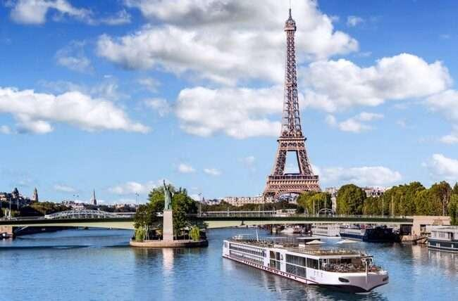

Highlights
- Value-for-Money holiday which you will cherish for a lifetime
- Tips USD 7.00 to coach drivers for the duration of the tour will be added and
collected with final payment per person per day.
- Visit 4 countries in 9 days: France, Switzerland, Austria and Italy.
- All Important attractions and sightseeing included. Guided tour of Versailles, Eiffel Tower 3rd level, Full day at Disneyland® Paris, River Seine Cruise, Excursion to Jungfrau included, Entrance to Mt. Titlis, Swarovski Crystal Museum, Visit to St. Mark’s Square with Gondola Ride, Photo stop at Leaning Tower of Pisa and entrance to Vatican Museum & Sistine Chapel with Local guide.
- Guided tour in Paris, Florence, Rome & Vatican Museum
- Services of a Professional & Knowledgeable Tour Manager accompanying you throughout the tour
- Accommodation in superior 4-star hotels
- Daily Continental buffet breakfast.
- Delicious unlimited variety of Jain, veg and nonveg Indian cuisine included as per itinerary.
- Daily mineral water bottle (500ml)

Day 1
Arrive into Paris - the City of Romance, Lights and Glamour.
Welcome! Today board our flight to one of the most beautiful and elegant city of Paris- known for its haute couture, renowned museums, breath-taking beautiful monuments and sensational cabarets. On arrival collect your baggage and proceed outside where you will be met by your professional tour manager, who will later escort you to your hotel. Check in and relax in the comforts of your hotel.
Overnight at the hotel in Paris. (Dinner)

Day 2
Guided city tour of Paris. Visit to Eiffel tower 3rd (Top) Level. Visit the Palace of Versailles, a testament to the pinnacle of French 17th-century artistry and achievement. Enjoy a romantic cruise on the River Seine.
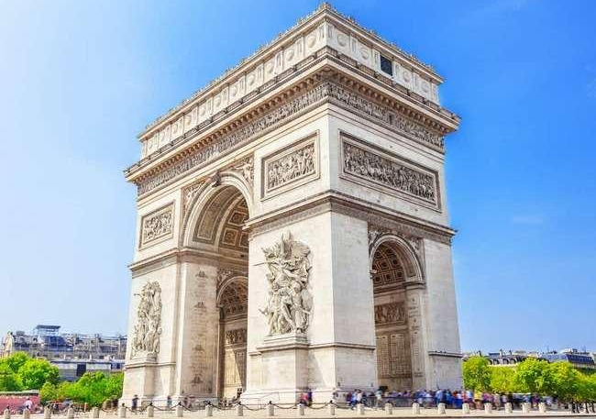
Today proceed for a guided city tour of Paris. Marvel at the finest Parisian tourist attractions, Place Vendôme, Place de l’Opéra Garnier, Musée d’Orsay, Place de la Concorde, Champs Elysées, one of the most recognised fashionable avenues in the world, Arc de Triomphe, Alexander Bridge, Les Invalides and several others. Next visit the iconic Eiffel Tower – 3rd Level, and get a stunning view of the city from the top. With its famous tapering cast iron tip, the Eiffel Tower is not just the symbol of Paris but of all of France. Our adventure continues with a visit to the Palace of Versailles, an internationally acclaimed masterpiece located in Versailles, approximately 12 miles (19 km) west of Paris, France. This magnificent palace is the property of the French Republic and has been under the stewardship of the Public Establishment of the Palace, Museum, and National Estate of Versailles, overseen by the French Ministry of Culture since 1995. Drawing in a staggering 15,000,000 visitors each year, the Palace, Park, and Gardens of Versailles rank among the most sought-after tourist destinations globally. Later take a romantic cruise down the river Seine, one of the world’s most scenic cruise, flanked by exquisite monuments like Notre Dame, Eiffel Tower, Louvre, Orsay Museum and many more. Gliding under one bridge to one another with a view of the finest monuments in the heart of bustling Paris.
Arc De Triomphe
(IMP NOTE - Please note that access to the Eiffel Tower's 3rd level is contingent on its operational status. If it happens to be closed during our visit, we will make the necessary adjustments and proceed to explore the 2nd level instead. Your experience will still be enriched by the fantastic views and the charm of the Eiffel Tower.)
Overnight at the hotel in Paris. (Breakfast, Lunch, Dinner)

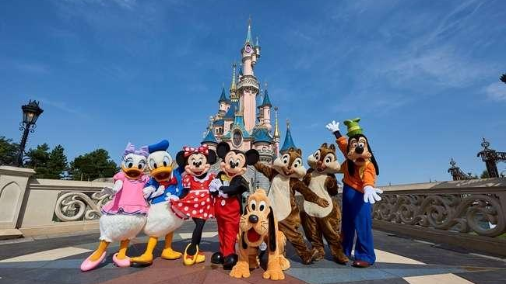
Disneyland® Paris

Day 3
Enjoy your fun filled day at Disneyland® Paris choice of Disney® Park or Walt Disney Studios® Park.
Get ready for a day full of excitement at Disneyland Paris- a popular amusement park. Enjoy different kind of thrill rides and studio movies with your loved ones. You may choose between Disney Park, where fairy tales take flight across five incredible lands filled with classic attractions, shows and street parades with Disney Characters OR you may visit the Walt Disney Studios Park Studios and be astounded by the outstanding stunt shows, watch a film being made and see real-life sets used for creating blockbuster movies.
Overnight at the hotel in Paris. (Breakfast, Lunch, Dinner)

Day 4
Drive to scenic Switzerland.
After checking out from your hotel, we will begin our journey towards Switzerland, a picturesque Central European nation characterized by its mountainous terrain, pristine lakes, charming villages, and the towering peaks of the Alps. As we embark on this scenic drive to Switzerland, you'll be treated to breath taking landscapes. Switzerland's mountains and valleys are renowned as some of the most awe-inspiring in the world, promising stunning vistas at every turn.
During your drive through these mountain passes, you'll encounter remarkable landmarks and sites of historical significance. Additionally, the majestic mountain panoramas that unfold before you are sure to leave you in awe.
Upon reaching Switzerland, we will proceed to your hotel, where you can check in and unwind in the cozy comforts of your accommodation.
Overnight at the hotel in Central Switzerland. (Breakfast, Lunch, Dinner)

Day 5
Visit Mt. Titlis- enjoy Cable car rides including the world’s first rotating cable car, the Rotair – to the top of Mt. Titlis at 3,020 metres. Enjoy a scenic cruise on Lake Lucerne.
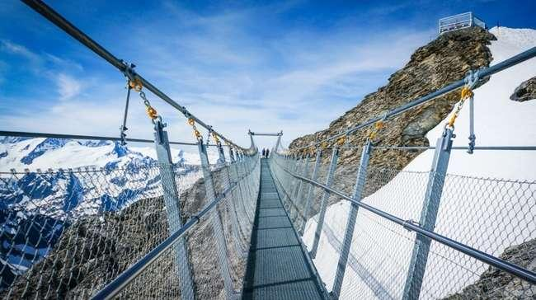
Today enjoy amazing scenery, a once in a lifetime experience with an exhilarating tip to the top of Mt Titlis at 3020 metres on various cable cars including Rotair, the world’s first revolving cable car. Get a breath taking unrestricted 360 degrees stunning view of the dazzling snow caped peak, deep crevasses and pristine white snow fields, dotted with massive ice boulders from every angle. Do not forget to visit the “Cliff Walk” the highest suspension bridge in Europe along the cliff of Mt.Titlis. Later proceed on an orientation tour of Lucerne one of most beautiful cities in Switzerland. Visit the Lion Monument, Kapell Brucke with some free time to shop for famous Swiss watches, knives and chocolates. Later enjoy a scenic and relaxing cruise on Lake Lucerne.
Mt. Titlis – Rotair
Mt. Titlis Cliff Walk
Overnight at the hotel in Central Switzerland. (Breakfast, Lunch, Dinner)

Day 6
Enjoy a magical alpine excursion to the top of Europe - the amazing Jungfraujoch which is included in your tour and scenic Interlaken.
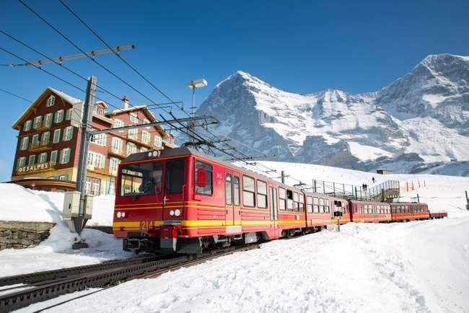
Get set for a memorable magical alpine excursion to Jungfraujoch – The Top of Europe, a high–point of your tour. First proceed to Grindelwald Terminal. The new 3S-Bahn Eiger Express takes you from the Grindelwald Terminal to the Eigergletscher station in just 15 minutes. There you board a cogwheel train to reach the highest railway station in Europe at 11,333 feet – a world of eternal ice and snow. Visit the Ice Palace where artistes create their work of art in ice. Visit the Sphinx observatory deck to experience a breath-taking panoramic view of the longest glacier in the Alps - Aletsch Glacier.
Cogwheel Train to Jungfraujoch included
Overnight at the hotel in Central Switzerland. (Breakfast, Lunch, Dinner)

Day 7
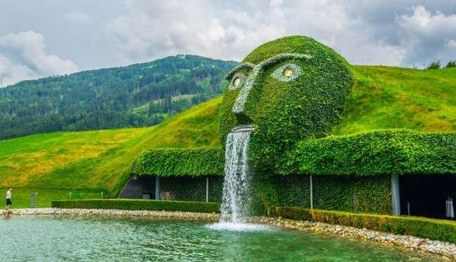
Visit the magnificent Rhine Falls. Visit Swarovski Crystal Museum – the dazzling world of crystals. Visit Innsbruck – The Tyrolean capital of picturesque Austria.
Today after breakfast, sit back and enjoy the scenic drive towards Schaffhausen, where you see the magnificent Rhine Falls – Europe’s biggest and most spectacular falls. Next we proceed to Wattens, where you'll have the opportunity to explore the Swarovski World of Crystals and be enchanted by the exquisite crystalline artworks on display.
Following this captivating visit, we'll continue on to Innsbruck, a city of extraordinary beauty. During our orientation tour, you'll have the chance to admire the iconic Golden Roof, known for its fire-gilded copper tiles, which serves as a defining landmark of Innsbruck. Stroll along the charming cobblestone paths of Maria Theresien Strasse, where you can choose to relax at one of the many outdoor cafes. As you do so, you'll be treated to magnificent baroque architecture and the chance to immerse yourself in the rich culture of medieval Europe. With the splendid Alps as a backdrop, the setting is nothing short of a picture-postcard perfect.
Swarovski Crystal Museum
Overnight in Innsbruck / Seefeld. (Breakfast, Lunch, Dinner)

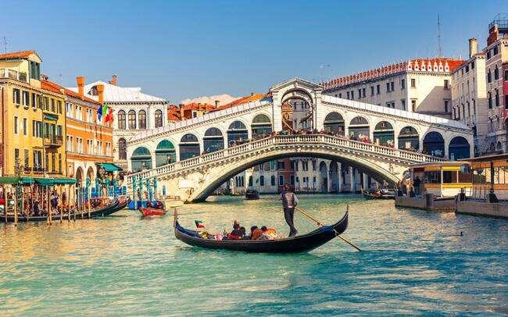
Gondola Ride
Day 8
Welcome to Venice - the floating city of Italy. Enjoy Gondola ride.
Check out of your hotel and proceed towards Venice – Italy. City of Beautiful Monuments, Serpentine Canals, city that inspired poetry and passion through the ages. Arrive at the pier in Venice, where we board a private boat. Enjoy your Indian lunch on board while you sail over the Giudecca Canal, to arrive at St. Mark’s Square – the main square of Venice. View St Mark’s Basilica - one of the best examples of Byzantine architecture, Witness the famed Bell Tower and Clock Tower with the dominant sign of the Zodiac and current phase of the moon. See the Bridge of Sighs, made of white limestone, that passes over the Rio di Palazzo, connecting the old prisons with interrogations rooms at the Doge’s Palace. Witness a Murano Glass demonstration and marvel at the intricate and colorful glass artefacts, hand-crafted by master craftsmen. Treasure a romantic Gondola ride in a flat-bottomed Venetian rowing boat, amidst the stunning backdrop of baroque buildings. This truly is the best way to enjoy this enchanting city. We return to the pier and later check in to your hotel.
Overnight in Padova/Bologna. (Breakfast, Lunch, Dinner)

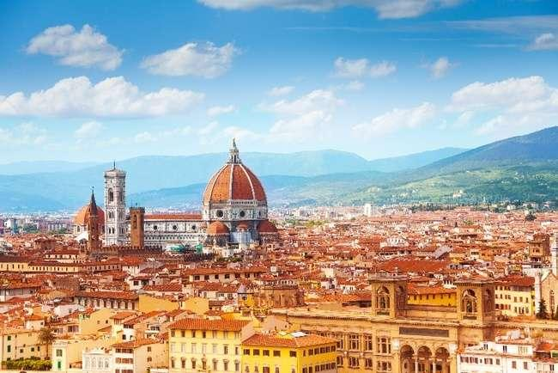
Day 9
Guided walking city tour of Florence. View the remarkable and famous Leaning Tower of Pisa.
This morning check out and drive to Florence – the cradle of the Renaissance. Along with your English-speaking local guide, walk and absorb into the culture of the historic city. View the Duomo – the city’s most iconic landmark, the Campanile and the Baptistery with its Gates to Paradise. Also see the Piazza Della Signoria – an open-air museum crammed with Renaissance sculptures, edged by historic cafes and presided over by the magnificent Palazzo Vecchio and the famed Ponte Vecchio (bridge) across the River Arno. Next, drive to Piazzale Michelangelo to get a spectacular panoramic view of the city. Later proceed towards Pisa. On arrival see the Square of Miracles with the stupendous Leaning Tower of Pisa.
Florence Duomo
Overnight in Tuscany region. (Breakfast, Lunch, Dinner)

Day 10
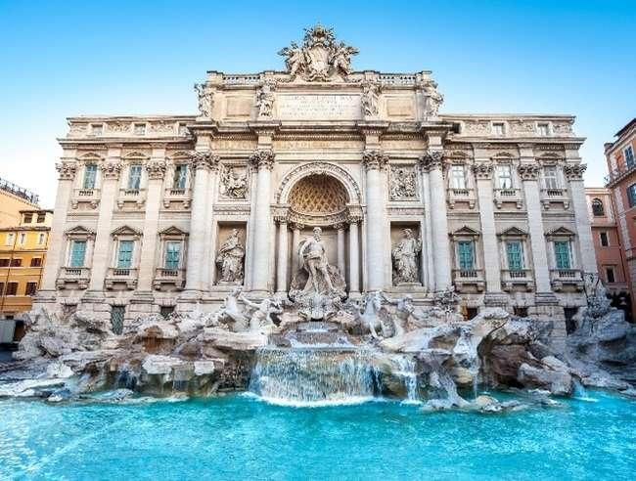
All roads lead to Rome – the eternal city. Visit the world’s smallest country – the Vatican City. (which includes Vatican Museum, Sisitne Chapel & St. Peter’s Basilica)
Today check-out and proceed towards the eternal city of Rome. Enjoy a guided city tour of Rome with an expert English-speaking local guide. Next visit the Vatican City – the smallest country in the world (Please note shorts or sleeveless vests are not allowed). Enter the Vatican Museum, where you see the renowned classical sculptures and masterpieces of the Renaissance Art. Visit Sistine Chapel – a source of inspiration for art lovers and tourists alike and known for its masterpiece – the Last Judgement. This is also where the Pope gets elected. Visit the divinely beautiful basilica of St. Peter’s. Get mesmerized by the works of Michelangelo and Bernini. We continue and then drive to view the magnificent Colosseum, a vast amphitheatre that is still well preserved. Next, Visit the beautiful Trevi Fountains. The Legend says that tossing a coin over your shoulder gets you back to Rome.
Trevi Fountain
Overnight in Rome. (Breakfast, Lunch, Dinner)
Day 11
Fly back home
Your memorable holiday ends, today it’s time to fly back home. Say goodbye to the wonderful new friends you have made on the tour. Check out and depart for the Airport with pleasant memories of your European trip which you will cherish for a lifetime.
(Breakfast)

Inclusion: Sightseeing and excursions

FRANCE
Paris
- City tour with a local guide
- Visit to the 3rd level of the Eiffel Tower
- Full day excitement and thrill at Disneyland® Paris
- Romantic cruise on River Seine

SWITZERLAND
Interlaken
- Excursion to Jungfraujoch - Top of Europe
- Visit scenic Interlaken
Engelberg
- Witness breath-taking mountain peaks and glaciers at Mt. Titlis
- Ride in the world’s first revolving cable car
- Walk on the Highest suspension bridge in Europe - Titlis Cliff Walk
Lucerne
- Orientation tour of Lucerne
- Lake Lucerne Cruise
Schaffhausen
- View the magnificent Rhine Falls

AUSTRIA
Innsbruck
- See the Maria Theresien Strasse and the Golden Roof
Wattens
- Visit the Swarovski Crystal Museum and shop

ITALY
Venice:
- St. Mark’s square by Private boat
- Enjoy a classic Venetian Gondola ride
- Visit the famous Murano Glass showroom
Florence:
- Guided walking city tour with a local English-speaking guide
Pisa
- Visit Square of Miracles
- Photo-stop at the Leaning Tower
Rome:
- Guided City tour with a local English speaking guide
- Visit to Trevi Fountain

VATICAN CITY
Vatican City
- Visit the Vatican Museum – see sculptures and masterpieces of Renaissance art
- Visit to the awe-inspiring Sistine Chapel
- Visit the magnificent St. Peter’s Basilica

Accommodation:
- 03 nights accommodation in B&B / Millennium / Hilton or similar hotel in Paris
- 03 nights accommodation in Radisson / Ramada / Movenpick or similar hotel in Central Switzerland
- 01 night accommodation in Alpenkoning / Alphotel or similar hotel Innsbruck / Seefeld
- 01 night accommodation in Four Points by Sheraton / Unaway / Capital or similar hotel in Padova / Rovigo
- 01 night accommodation in B&B / Park / A Point or similar hotel in Tuscany
- 01 night accommodation in SHG / Hampton by Hilton / Marriott or similar hotel in Rome

Meals
- Daily Continental Buffet Breakfast.
- 9 Indian Jain/Vegetarian/Non-Vegetarian/Local Lunches.
- 10 Indian Jain/Vegetarian/Non-Vegetarian Dinners.
- Daily Mineral Water Bottle (500ml)
(Packed lunch will be served on the day you visit Disneyland Paris)
Driver Tips:
Tips USD 7.00 to coach drivers for the duration of the tour will be added and collected with final payment per person per day.

What your tour price does not include:
- The cost of the Airfare, Passport, POE charges, Visa charges, Overseas Travel Insurance, medical expenses, etc.
- Any expenses of personal nature such as Porterage, Laundry, and Alcohol, Food or Drink not in the regular menus provided by us, mini bar and telephone calls
- Any extra meals not included in the itinerary. Meals are pre - set and a choice of menu is not available
- Cost of excursions, city sightseeing, entrance fees and local guides availed of by the passengers, other than that mentioned in ‘What your tour price includes’
- GST, TCS and other taxes as applicable
- Anything which is not specified in the Itinerary
- Any items not in itinerary and / or not listed in inclusion will be cost extra
- If your flight arrival departure is early or late, they have to make their own arrangement to/ from airport/ hotels, etc.

Instruction for Arrival & Departure Coach Transfers:
Paris (CDG Airport) Arrival Transfer: Flight landing time should be between 08 AM – 02 PM.
Rome (FCO Airport) Departure Transfer: The coach will drop at FCO Airport by 1100 AM.
If your flight arrival departure is early or late, they have to make their own arrangement to/ from airport/ hotels, etc.

IMP Notes for Transfers:
- Please advise your client that there may be waiting up to 02 Hours (Post reaching in arrival hall) for arrival transfers.
- If flight timings are before / after the suggested timing, client has to arrange his private transfers on direct payment basis. We will not reimburse any cost for private transfers.

NOTES:
- A person below 12 years of age on the entire tour will be considered a child
- As a 3rd person in a triple room, most hotels use rollaway beds and room size may be the same as the double room
- Tours will operate subject to all Government regulations
- All Local taxes, entrances and services are calculated as on 1st October 2021, any increase in local taxes, entry tickets and other services has to be borne and paid by the traveler/agent.
- All transfers and extensive sightseeing with entrance fees (as specified in the itinerary) will be done in an air-conditioned coach
- On reaching Eiffel Tower, if there is a very long queue, we will be taking you to the Montparnasse tower
- It is suggested to carry One check in bag and one hand bag per person only, due to limited boot space in the coach
- Services of our Tour Manager or local representatives, while on tour
- On some occasions, you may have to join another group in case your group does not have adequate members
- A local representative or your coach driver may only be there to assist you during your initial part of the tour
- Land surcharges applicable on certain departure dates which will be notified
- If certain sightseeing/excursions are closed, then alternate sight- seeing will be arranged.
- Kindly note that on certain departure dates the tour routing could change. In some tours, there is also a possibility that the tour could operate in reverse itinerary. However, you will not miss any sightseeing or excursions that are mentioned in the itinerary unless its closed due to a holiday. Your Tour Manager will notify you the same
- In case of inordinate delays and strict driving laws, packed dinner may be provided on that day
- Please check with your Sales representative for final details
- In case of any increase in any taxes in Europe, there would be a change in price which will be justified
- We reserve the right to claim from the passengers, any additional expenses incurred due to delay or changes in the schedule of trains, flights, coach, cruise or other services
- We reserve the right to change any itinerary for operational reasons and reasons beyond the control of us due to Force Majeure related to weather conditions, strike, etc. Force Majeure related to weather conditions, strike, etc.
- We shall not accept any liability or responsibility for any damages, loss, injury, accident, death, delay, breakdown or irregularity, which may occur during the tour, due to weather conditions, strikes, war, quarantine and or any other cause whatsoever and all such loss or expenses must be borne by the passenger
- Tours are operated subject to Reserve Bank of India / Government of India regulations
- Tour cost is payable in EURO out of your BTQ entitlement of the passengers

