Eastern Explorer
7 Days / 6 Nights
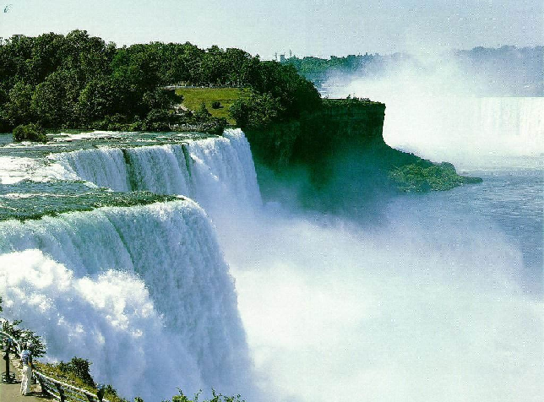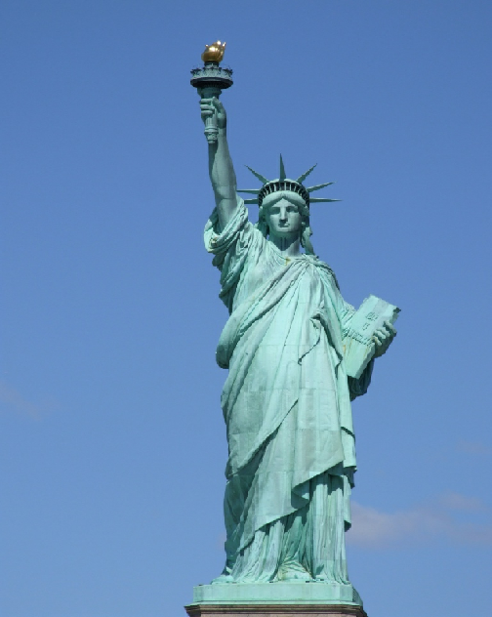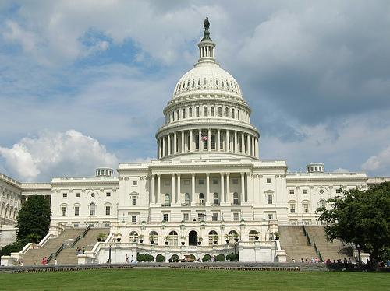
Departure Dates 2026
Departur Dates:
April | 16^{th,} 30th
May | 14th, 28th
June | 18th
July | 9th
AUG | 6th
SEP | 10th
OCT | 20th

Cost in USD PP:
Single | $2,873.00
Double | $2,276.00
Triple | $2,139.00
Quadpp | $2,019.00
Child | $1,710.00

DAY 01 - ARRIVE AT NEW YORK
Welcome to the "Big Apple, The City That Never Sleeps"—New York is a city of superlatives: America's biggest; its most exciting; its business and cultural capitals; the nation's trendsetter. It is one of the world's major centers of commerce and finance.
Upon arrival at the airport, the driver will meet you and transfer you to the hotel. Airport transfers from JFK will be from 11 am to 2 pm. Should you arrive after this time you can take a taxi to the hotel or please see the optional section for rates for transfers.
After arrival at the hotel, check in, take some time to freshen up and meet in the hotel lobby for dinner (approximately 7.30 pm), following which we will head to Times Square.
Known as "The Crossroads of the World" and "The Great White Way," Times Square NYC is one of the most popular commercial intersections in the world. Located in central Manhattan at the junction of Broadway and Seventh Avenue, it is home to top destinations such as ABC's Times Square Studios, and Planet Hollywood. More than 300,000 people pass through iconic Times Square NYC every day.
Free Time at Times Square. You can opt to see Madame Tussauds wax museum in Times square, RISE NY or go to see Broadway Show are the theatrical performances presented in the 41 professional theaters, each with 500 or more seats, located in the Theater District and the Lincoln Center along Broadway, in Midtown Manhattan, New York City (Refer to optional section for details and pricing)
Dinner at restaurant & transfer to hotel for overnight stay. (D)
DAY 02 – NEW YORK CITY TOUR WITH STATUE OF LIBERTY & SUMMIT ONE VANDERBILT
After breakfast, we proceed for a Full day city tour of New York.
First, we will head to Battery Park for a 15 min ferry ride to see USA’s famous landmark, “Statue of Liberty”. This is one of the most recognized symbols of freedom and democracy in the World. The Statue was a gift from France to USA in 1885. Tour the grounds and take pictures with Lady Liberty. We will proceed back to Battery Park to continue with our guided city tour with our tour guide. We will make a photo stop at the iconic Wall Street bull. This is a 7001-pound structure at the financial district in Manhattan, depicting a charging bull, the symbol of aggressive financial optimism and prosperity. Later we drive through Rockefeller Center, Ground Zero, United Nations and Trump tower. We will then proceed to visit SUMMIT One Vanderbilt. Explore three levels of mind-bending multi-sensory immersive experiences set atop the tallest commercial skyscraper in Midtown Manhattan. It offers three levels of multi-sensory immersive experiences. Here, you can enjoy panoramic views, marvel at mirrored rooms and art installations. Transfer to a restaurant for dinner. After dinner, transfer to the hotel for an overnight stay. (B, D)
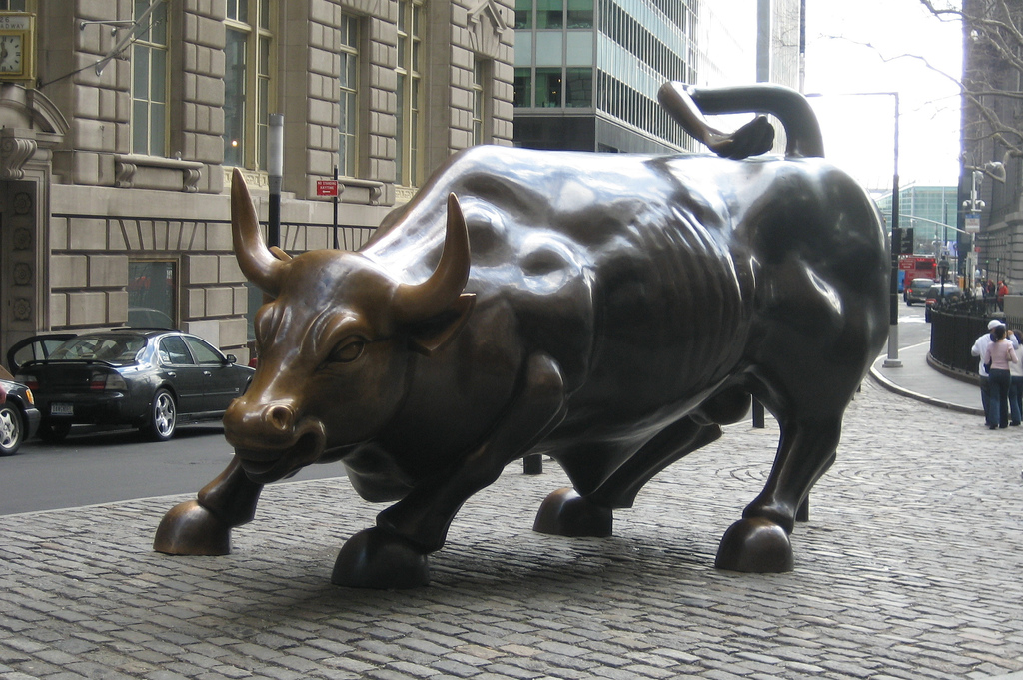

DAY 03 - NEW YORK – PHILADELPHIA – WASHINGTON, DC.
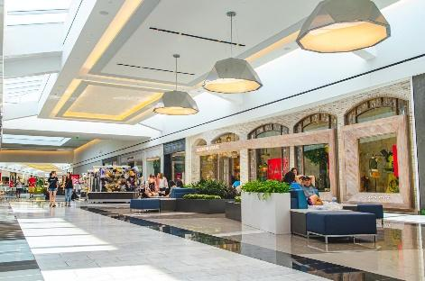

After breakfast, we check out of the hotel and drive towards Washington DC (approximately 5-hour drive).On the way, the Philadelphia orientation city tour explores the highlights of the city. Visit all the must-see spots, like Independence Hall and the Liberty Bell Exhibit, the South 9th Street Italian Market, Philadelphia City Hall, Love Park, the Rocky steps at the entrance to the Philadelphia Museum of Art and much more.Make your way over to the iconic Tax-Free Shopping on clothing and shoes at King of Prussia Mall. This is the largest retail space in the U.S., with more than 450 stores like Nordstrom, Bloomingdales, Christian Louboutin, Tiffany & Co, Macy’s and an impressive collection of luxury retailers, such as Cartier, Gucci, Louis Vuitton and Williams-Sonoma. Spend the evening at world-renowned Longwood Gardens: 1,077 acres of botanical bliss. Meander 20 outdoor gardens and surround yourself in flowering flora in the grand conservatory. Longwood boasts the most significant fountain collection in North America. The Main Fountain Garden’s 1,719 jets soar as high as 175-feet by day.Proceed to Washington DC, on arrival proceed to dinner before checking into the hotel. (B, D)
DAY 04 - WASHINGTON – Guided City Tour & Visit Smithsonian National Air and Space Museum & Sightseeing Cruise.
After breakfast, Proceed to Guided city tour of the capital of USA. You will be met by an experienced tour guide for a 3-hour guided city tour. Washington DC is the capital city of the United States of America. It is a city of monuments, memorials, historic neighborhoods, and museums. We will take photo stops at the White House, the home of the President of the USA. Lincoln Memorial, Supreme Court, the Capitol Building, Union Station, World War II Memorial Building, Pentagon, Washington Monument, Congress Library. After the city tour, we will visit the Smithsonian Air and Space Museum. The Smithsonian National Air and Space Museum maintain the largest collection of historic air and spacecraft in the world. The museum features 22 exhibition galleries, displaying hundreds of artifacts including the original Wright 1903 Flyer, the "Spirit of St. Louis," and the Apollo 11 command module. The National Air and Space Museum is a must-see for visitors to Washington, DC. It is the most visited museum in the world and appeals to all ages. Travel along the Potomac River by Cruise to see the plethora of famous monuments and landmarks, with stunning reflective views of the Thomas Jefferson Memorial, the Lincoln Memorial, the Washington Monument, and more. Dinner at a restaurant. After dinner transfer to the hotel for an overnight stay. (B, D)
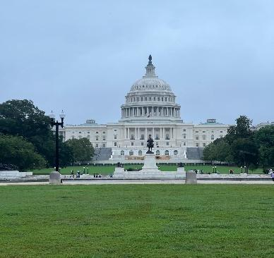

DAY 05 – WASHINGTON, DC to NIAGARA Falls (US SIDE) Via Hershey’s:
After breakfast, we check out of the hotel and drive towards Harrisburg, where we will visit the Hershey’s Chocolate Factory (approximately 2.5 hours’ drive)
Hershey is the largest manufacturer of chocolate in the world. Discover all things chocolatey and fun at Hershey's Chocolate World Attraction! Embark on a journey to learn and see how chocolate is made on a tour ride, and shop for one-of-a-kind souvenirs and gifts, and have a chocolate inspired adventure. After visiting Hershey Chocolate factory, we will drive to Niagara Falls, NY. (5.5Hrs Drive)On arrival, proceed for dinner before checking into the hotel. overnight at Niagara Hotel. (B, D)
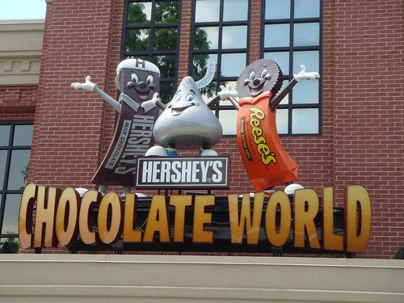

Day 6. MAID OF THE MIST, CAVE OF THE WINDS & FALLS VIEW BALOON
After breakfast we will be walking to board the famous boat, “Maid of the mist”. This boat ride takes close and around the American and Horseshoe Falls.
Later, proceed to The Cave of the Winds, which takes you closer to the waters of Niagara Falls than you thought possible. You will ride an elevator 175 feet (53 meters) deep into Niagara Gorge. Then, clad in a bright yellow poncho and wearing the special footwear provided, you will walk over a series of wooden walkways to the famous "Hurricane Deck". As you stand at the railing, you are a mere 20 feet (6 meters) from the billowing torrents of the Bridal Veil Falls.
Free time at the Falls on your own. Evening gets ready to experience Niagara Falls, USA’s Newest Attraction! Take to the skies aboard the Falls view Balloon — an awe-inspiring aerial adventure that lifts you up to 500 feet for sweeping, panoramic views of one of the world’s most spectacular natural wonders. The Falls view Balloon ride is perfect for families, couples, adventure seekers, and video and photo enthusiasts alike.
Walk for dinner, after dinner you can opt to walk to the falls to watch the Niagara Illumination. Walk back to hotel. Overnight in Niagara. (B, D)

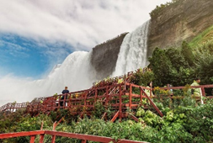

DAY 7: DEPARTURE FROM NIAGARA
After breakfast proceed to Buffalo airport for your flight to the next destination/home.
OPTIONAL COSTS – Hotels /transfers

Pre-Tour Hotel Night at Holiday inn Manhattan or similar per person
DBL | TRL/CWB | SGL | QUAD
$195 | $170 | $390 | $135
Supplement cost per person for private airport transfers
from JFK airport
1 pax | 2 pax | 3 pax | 4 pax
$200 | $110 | $95 | $75
TO buffalo airport
$175 | $95 | $70 | $55

OPTIONAL COSTS – SIGHTSEEING:
Madame Tussauds wax museum (times square) general admission tickets only: $ 55 pp
Get up and close with your favorite celebrities at New York City's Madame
Tussauds in Times Square. This is the only place where you can become a Ghostbuster, a superhero, and a celebrity all on the same day.
Helicopter ride over Manhattan (15 min): $315 PP
Take a flight that you will remember for a lifetime! Departing from the Downtown Manhattan Heliport, the Classic Manhattan Tour begins at the majestic Statue of Liberty, followed by the world-famous Manhattan Skyline. Price excludes $35 per person helipad fee to be paid directly.
Beast Ride - $45 PP
Ride a rollercoaster on the water with this beast ride. The Beast has 1400 BHP-horsepower with two ZF 3000 marine gears powered by twin Hamilton Jets, allowing the boat to rocket through the water at up to a heart-pounding 40 knots (about 45 mph).
RISE NY - $ 65 PP
Rise NY’s immersive three-part adventure takes you on an immersive journey through the evolution of NYC's vibrant pop culture history, connecting you to some of the city's most famous sights and historical moments!
AQUARIUM OF NIAGARA - $ 35 PP
Experience the underwater world at the Niagara Falls aquarium, boasting over 30 impressive exhibits and more than 200 aquatic animal species.
Price Includes:
- Arrival/Departure airport transfer.
- 6 nights’ accommodation with breakfast.
- 6 dinners @ Indian Restaurants (set menu)

- New York Hotel
Millennium Broadway /Doubletree by Hilton or similar
- Washington Hotel
Holiday Inn Greenbelt /Crowne Plaza College Park or similar
- Niagara Falls Hotel
Sheraton at the Falls Niagara Falls /Holiday Inn or similar

- City tour: New York, Philadelphia & Washington, DC.
- Entrance tickets: Statue of Liberty, Summit one Vanderbilt, Longwood Garden, Smithsonian Air and Space museum, Capitol Building from outside, Union Station, Potomac River Cruise, Hershey’s Chocolate Factory, Maid of the mist, Cave of the winds & Fall view balloon ride.

Price Excludes:
- Any airfare, visa/ ETA, City and hotel tax, baggage charges and overweight baggage,
- Meals, drinks, extra water, except those indicated above.
- No vehicle at disposal in Niagara as all attractions are within walking distance.
- Any item(s) not listed in inclusions.
- Porterage, travel insurance, medical expense, tip drivers guide 5.00 USD per person per day.
- Personal expenses of any nature like laundry, shopping, incidentals at hotels and vehical etc.
- Any tours, transfers or event tickets are not mentioned in the package included.
- Incidental Charges must be paid by travelers themselves.

TERMS & CONDITIONS:
- There is a mandatory charge of a minimum of $5 per person per day towards driver’s tips to be paid directly to the driver/tour manager on day 1. This cannot be prepaid.
- Time wise itinerary is given to make your trip most enjoyable and should be followed religiously.
- All bookings that are received within 14 days of the tour are subject to a $35 per person Service Fee.
- The size of the vehicle will vary based on the number of pax.
- The passengers requiring wheelchair assistance should make their own arrangements for the wheelchair and inform us 2 weeks prior.
- All tours and ticket rates are subject to change based on availability and supplier surcharges.
- Hotel breakfast is included at the hotel and cannot be packed. Breakfast may not be open if clients have early flights/tours.
- After covid, Full American breakfast may not be available at hotels, they may have grab n go, Plated, continental, or plated option available.
- Surcharges for weekends and conventions may apply for any trade fair/special event in the city.
- To ensure the highest quality and services, the registration form must be completed in full.
- Hotels will require your credit card / cash for the security deposit.
- Child age 2-9 years. Above 9 years is considered as an adult.
- All rates and availability are subject to change at the time of booking.
- Some events are seasonal like Maid of the Mist, Cave of the Winds, Beast Riding, Yosemite Park, Lake Tahoe etc. (Will be closed for winter)
- Early check-in requests will be made on a first come first serve basis, however cannot be guaranteed unless prior night has been prepaid.
- We reserve the right to use alternative accommodation, sightseeing tours, and transfer of equal or higher standards.
- No refunds either in part or full will be made for any unused services in the above package like ground transportation, meals, accommodation, sightseeing tours.
- We are not responsible for any baggage charges by any airline for the clients.
- Payment for the tour must be made as per the invoice & payment terms & conditions.

Payment Terms:
- 25% + plus 100.00 non-refundable deposit to be paid at the time of the booking.
- 75% payment to be made 60 days prior to the date of travel.
- 25% Balance payment to be made 45 days prior to the date of travel.

Cancellation policy – all cancellation should be in writing only via email: krishnatours3692@gmail.com
  - 41 days or more prior to departure date USD 100.00 deposit will be deducted plus any airfare we booked.

  - 40 to 22 days prior to departure date 65% of the tour cost any non-refundable airfare USD 100.00 deposit will be deducted plus any non-refundable airfare.

  - 21 - 0 (Zero) days prior to departure date full payment of the tour cost 100% plus any airfare airfare.

